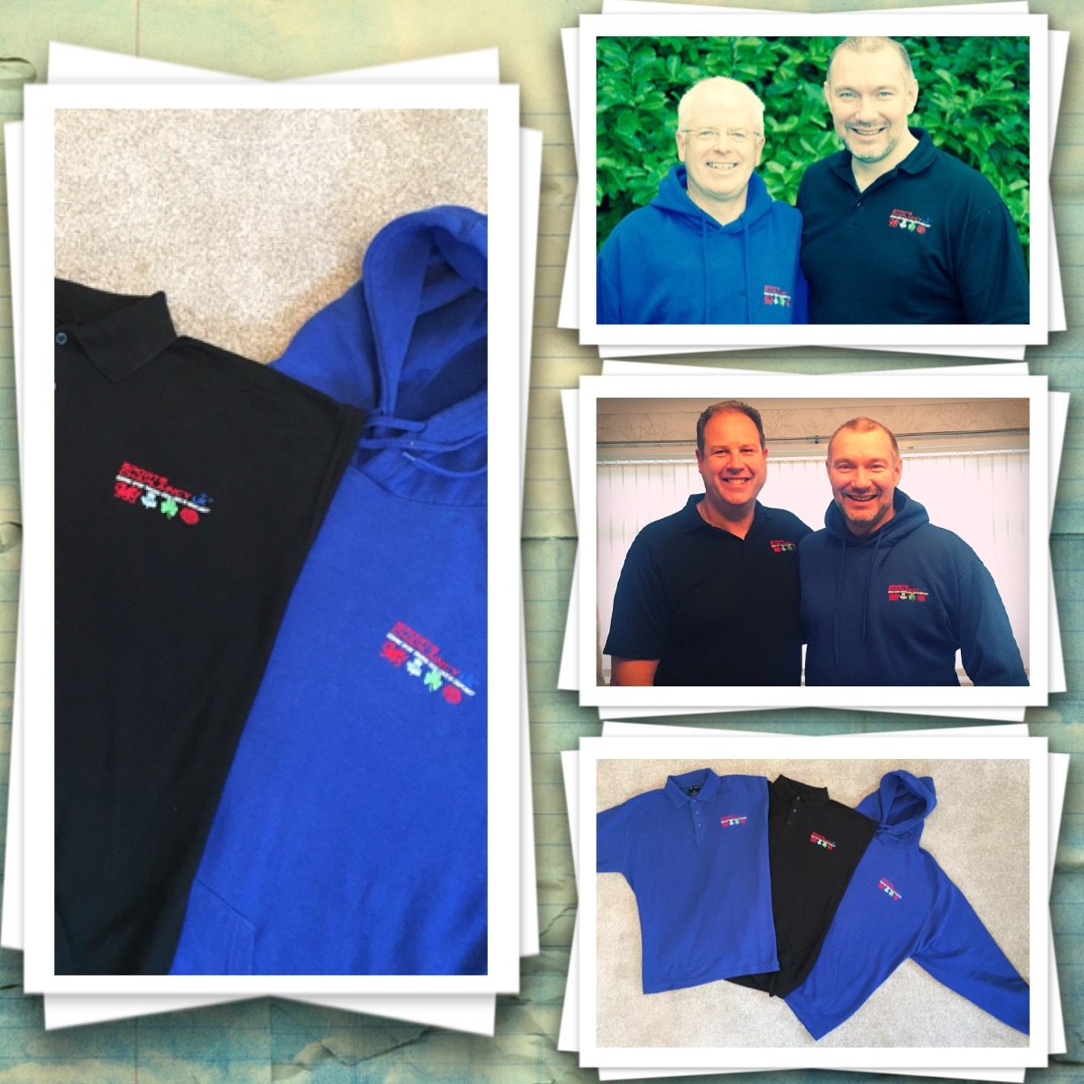
T-Shirt/ Hoodie Order Form
Name:
Postal Address:
Post Code:
Email:
Mobile/Phone No:

T-Shirt Order (Price per item £12.50)
Please indicate number of t-shirts in the box i.e. 1 or 3

Colour:
Black |  | Blue |  | Green |  | Red

Size:
S |  |  | M |  |  | L |  |  |  | XL |  | XXL |  | XXXL
Hoodie Order (Price per item £22each)
Please indicate number of t-shirts in the box i.e. 1 or 3

Colour:
Black |  | Blue |  | Green |  | Red

Size:
S |  | M |  | L |  | XL |  | XXL |  | XXXL

Logo:
SCUK OTHER SPECIFY

If you wish to have your name embroided under the logo please specify in the box below
Cost per item £3

Total Cost Order £ Payment Received – Sheet attached

