Ironman World Championships October 2017, Kailua-Kona, Hawaii

A 2.4 mile swim in Pacific Ocean, 112 mile bike through lava fields north of Kona, 26.2 mile run through Kona then out into the lava fields and back. Temperature range 32-43°C, no cloud cover, winds gusting at 35+mph.

Some like it hot .... but not me!

I arrived 4 days before the race with husband Mike and son John. It was the earliest we could manage, but much less than the recommended 3 weeks to get over the jet-lag and acclimatise. I compromised, forcing Mike to suffer with the hotel air con off! It was very busy pre-race with bike re-building and checking, athlete registration, the parade of nations, Ironprayer Hawaiian style, a mandatory briefing and the fun bit - the underpants charity run with John. And I had the immense privilege of meeting the legendary Rick Hoyt and his father Dick.

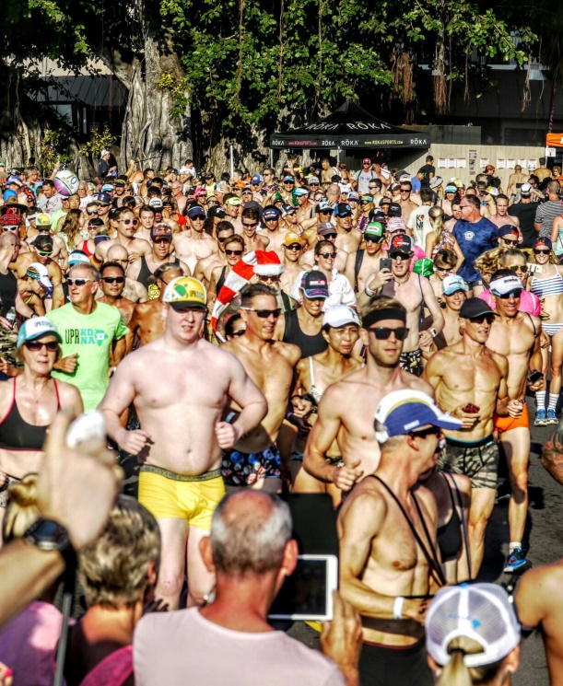
Underpants Run

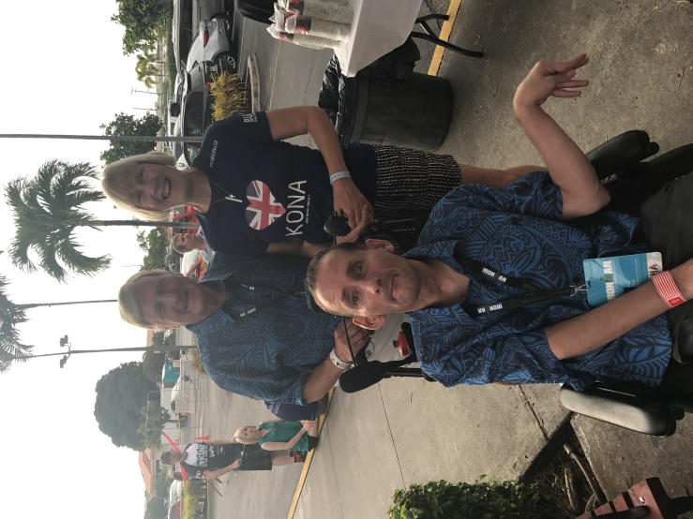
Team Hoyt

Kona was full of lean, fit, lycra-clad athletes cycling, running, swimming, stretching in the pre-race frenzy. It would be easy to get caught up in it and to feel totally inadequate. I tried to remember I had earned my place here at a tough race and much more importantly, God wanted me to be here.

After bike racking on the Friday, my usual feelings of dread of the pain and effort to come on race day hit hard. Why was I doing this? I get sunstroke, heatstroke and burn easily. I've spent the last few years acclimatising to cold water, snow and ice. What hope did I have of surviving a long day in temperatures of 40°C? I decided the only way was ‘Yukon-style’, putting body management and respect for the environment ahead of speed.

Race morning dawned hot and cloudless. I joined the long queue of athletes for body marking, weighing, bike sorting and getting ready for the swim. The pro-men were off at 0635, followed by the pro-women, then the male age-groupers at 0705 and the women at 0720. That was both good and bad. Good that I wouldn't get swum over too much and it would be very easy to find my bike, but bad because it would be a rougher swim and ride as the winds rose.

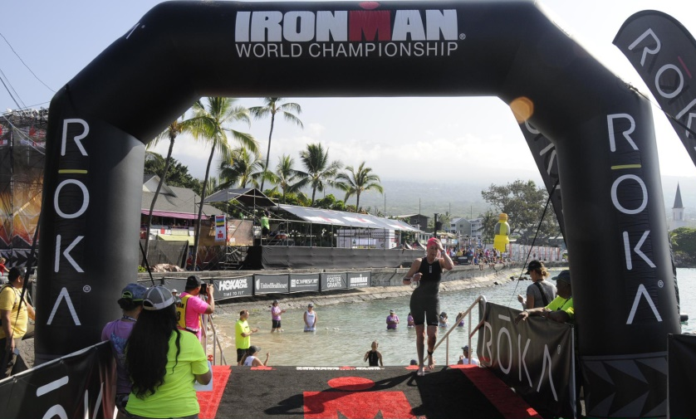
Swim exit
Swim Exit
The swim was ok. A bit of wind-chop and some Pacific rollers further out but bearable. Probably shouldn't have wasted time telling a paddle boarder about the Ironman swim hat I could see on the bottom, or watching the turtle swimming around near the beach. Finished in 1:47, a few minutes better than my last time here in 2008.

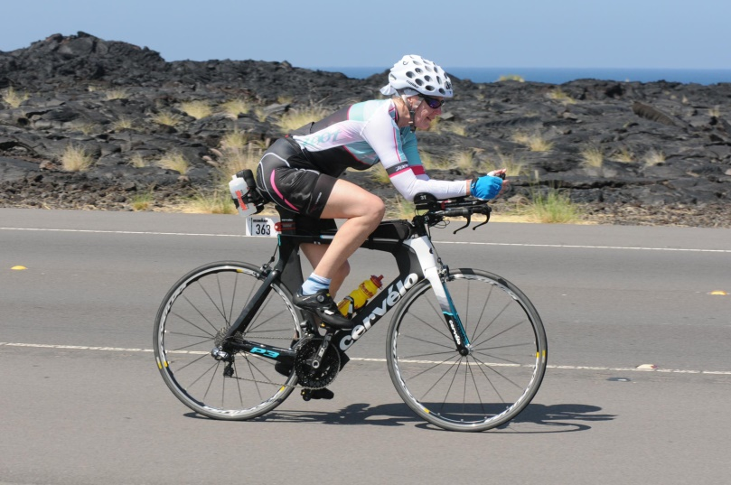
I took my time in T1, putting on sleeves, cycling top and gloves to protect against sunburn and drinking coke to get rid of the salt. But eventually I ran out of excuses, and went out on the bike leg. The first 25 miles or so through Kona and out onto the Queen K highway through the lava fields were good. I stopped at every aid station to eat bananas, pour water and ice over myself and get more sunscreen. I was riding faster than several of my fellow athletes, but they often overtook me again as I stopped at the aid stations. The sun was relentless and the temperatures rising. What sensible human being would go out in this? Then in the hottest part of the day at 59 miles we turned off the Queen K highway and started the climb to the turnaround at Hawi. And the winds rose. A vicious, gusting crosswind at first, turning into a full-on headwind for the final 5-6 mile climb into Hawi.
Through the lava fields

The descent from Hawi was a nightmare. The crosswind was strong and unpredictable, with gusts that could have you off the bike in an instant. At 30mph plus I did not want to hit the tarmac. I could hear a Japanese woman behind me screaming. The screaming continued so I knew she hadn't come off. I cried out to God to keep me safe. By the time I got down my left arm and hand were numb from holding the bike against the wind.

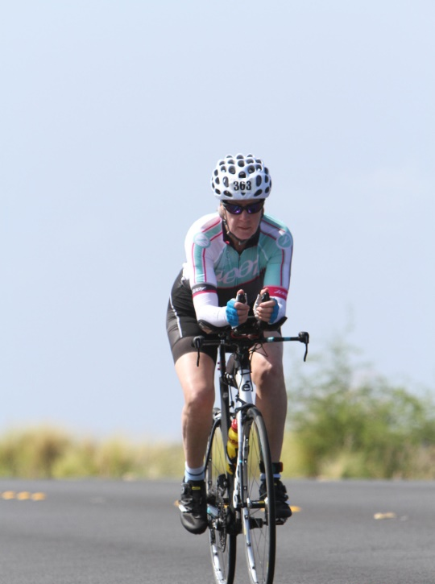
Back on the Queen K highway there were only 34 miles left and I was set for a 7:30 bike leg. But a strong, malevolent headwind had developed. A volunteer at the aid station confirmed it had only risen in the last hour so the earlier competitors had missed it. The wind lasted head-on all the way to Kona. At times I was working hard pedalling downhill at 8mph. It was a physical, mental and spiritual battle. And it was so hot - apparently 38°C in Kona and 43°C out on the highway.

Eventually I crawled back into T2 with a bike time of just under 8 hours. It was the hardest bike ride I can remember.
Battling the headwinds back into Kona

Again I took time in transition to drink and put on yet more sunscreen. I stopped for a hug with Mike and headed out for Alii Drive and the first part of the run.

Trying to remember how to run
This was always going to be run/walk - I was just hoping for more run than walk. Eventually I settled into 100 steps walk, 200 run unless it was a downhill which had to be run. I still stopped at every aid station for food, drink, water and ice. Getting to the end in reasonable shape was more important to me than speed. I had a lovely hug from John outside our hotel - does being lifted off the ground in a bear hug count as outside assistance? Then up onto the highway in the dark and I hit a low spot at around 15 miles. It was an effort to force food down, although the chicken soup helped. Once I reached the turning for the Energy Labs at about 17 miles I felt better.

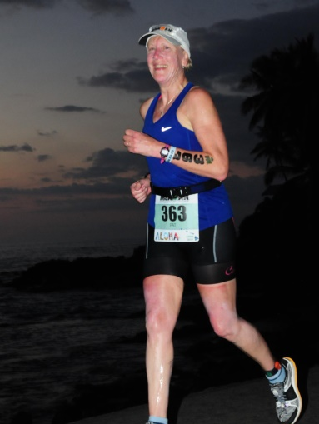

I was still passing people both running and walking, although there was less running now. The miles ticked away and I could hear the noise from the finish line on Alii Drive. I ran down into Kona from the highway, two more turns and suddenly there it was - the finish. People crowded on both sides of the red carpet. Another massive hug from John, a kiss from Mike on my way down the red carpet and I crossed the finish line after 16 hours and 11 minutes.
Still running much later

It was not a fast time (although 34 minutes faster than 2008) but the strategy worked and I survived the furnace with no dizziness, heatstroke, dehydration or stomach issues and still feeling relatively strong. The sunburn on my legs and wrists was quite severe - but would have been much worse if I hadn't stopped for extra sunscreen.

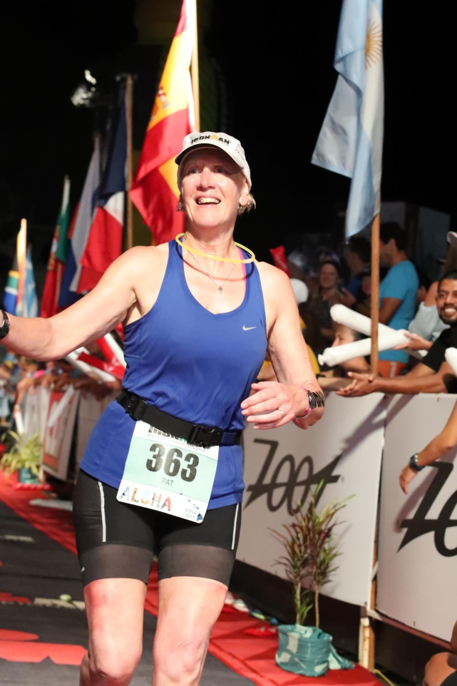
Finish line

I thank God for the opportunity to race in Kona, and for His love, strength and protection. I thank my family for their unwavering support of mum's madness, and all those people who have prayed for me, encouraged me, sent me good wishes and positive thoughts, laughed with me, hugged me and cried with me. Thank you for being part of my adventure. God Bless

Pat Cooke-Rogers
October 2017

