Section 1 – Introduction

What is Mental Health? (and why does it matter?)
It is a level of psychological wellbeing and includes our thoughts, emotions, moods, behaviours
It impacts on what we do and how we do it, like communicating, relationships, making choices
It’s affected by things in our lives like influences, experiences, backgrounds
and……… We ALL have it!
- Mental health is not the same as 'mental illness'
- ‘A mental illness is a problem that affects mental health (just like a broken leg affects physical health)’.
(Well Scotland)

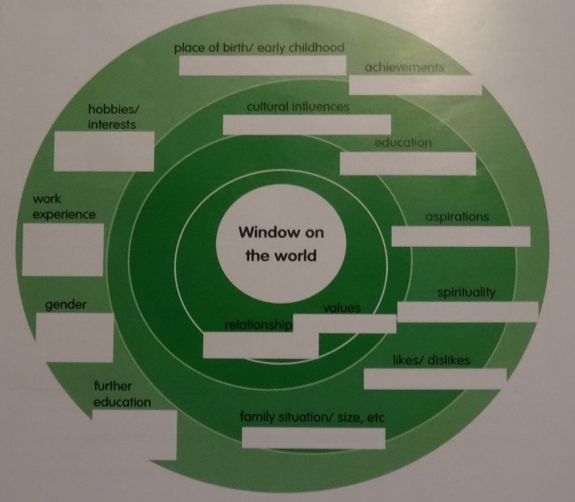
All of us have filters through which we view the world around us.
These filters have been created by various things:
our nature
upbringing
education
culture
belief system
life experience.
And we’re all PREJUDICED!

Take some time to consider how you view people with a mental illness and why…

The Mental Health Continuum
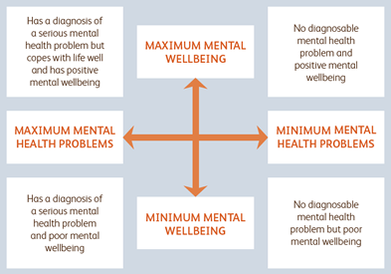
Section 2 - Depression

What is the difference between a low mood and clinical depression?
Low Mood
Caused by circumstance
Affected by circumstance
Short term
Depression
Possibly but not necessarily triggered by circumstance
Not possible to simply lift yourself out of it
Long term and potentially debilitating
Impacts on self-confidence, self-esteem and quality of life!

What is clinical depression?
A clinical depression lasts for at least two weeks and affects how a person thinks, feels and behaves. It is likely that there will be physical, psychological and behavioural symptoms. Depression can affect a person’s relationships, work and even basic tasks

How a doctor diagnoses depression
Over a two week period 4 symptoms could mean you have mild depression, 6 = moderate depression and 8 or more = severe depression

Symptoms of depression
Physical can include: weight loss/gain, sleep deprivation/excess
Psychological can include: poor self-esteem, low self-confidence, struggling to concentrate, repetitive thoughts, confusion, over emotional/non-emotional, suicidal thoughts
Behavioural can include: withdrawing from company, irritability, being erratic, appearing lethargic

Possible Signs and Symptoms of Depression
- Marked decline in school or on-field performance
- Reckless behaviour on and off the field
- Unusual negative reaction to peers or coaches
- Unusually withdrawn from others, avoiding social situations
- Lack of energy, motivation
- Extreme difficulties in concentrating that affect being coached
- Absenteeism/ feigning injury
- Complaints of unexplained aches and pains

Risk factors for depression
- Serious injury
- Loss of form
- Level of expectation from parents
- Being released from a club
- External factors such as bereavement, family illness
- Hormonal changes in females
- Issues surrounding sexual orientation, bullying, discrimination
- Culture shock, isolation (S.A.D syndrome)
- Family history of depression
- A difficult childhood, an early and unsupported bereavement
- Nothing in particular!

What do you do if you recognise signs or symptoms that someone has depression?
- Unless you’re a doctor – don’t diagnose!
- Ask the person (seriously, sincerely!!!), “How are you?”
- Say to them, “I’ve noticed…” (without judgement/criticism)
- and “…and I’m concerned about you”
- Ask them, “How are these things affecting you…”

Encourage Appropriate Professional Help
- Understand they there may be anxiety about going to a club doctor/GP
- Consider offering to accompany the person
- Explain various potential options – e.g. private counselling, cognitive behavioural therapy
- Give them hope that with the right support their recovery is possible and likely!
- Follow up by asking how they got on

Black Dog
https://www.youtube.com/watch?v=XiCrniLQGYc
Living with the Black Dog
https://www.youtube.com/watch?v=2VRRx7Mtep8

Section 3 – Anxiety Disorders
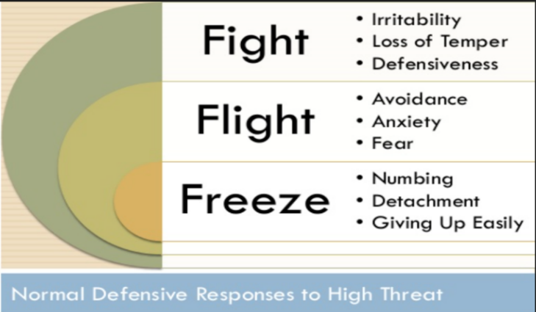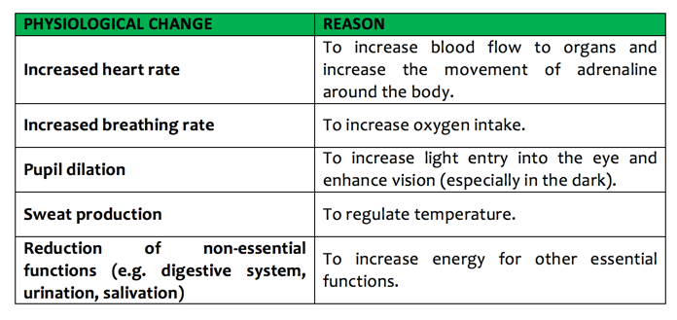

Fight/flight/freeze
The amygdala part of the brain doesn’t differentiate between:
Either perceived/actual threat or present/remote threat

Signs that someone has an Anxiety Disorder
Are they:
Constantly on edge, tense, worried?
Plagued by fears that appear irrational?
In significant distress that interferes with everyday life?
Do they:
Believe that something bad will happen if things aren’t done a particular way?
Feel that danger is around every corner?
Experience unexpected, sudden panic attacks?
Avoid certain activities or situations without reason?

Helping someone with an Anxiety Disorder
- Accept their fears are real to them - don’t judge, criticise, trivialise what they’re experiencing
- Acknowledge the distress that they are living with
- Listen with compassion about how this is affecting them
- Encourage them to see a G.P/club doctor (offer to accompany)
- Explain that they will provide a full physical check-up
- They may prescribe medication and recommend CBT (Cognitive Behaviour Therapy)

What is Cognitive Behaviour Therapy?
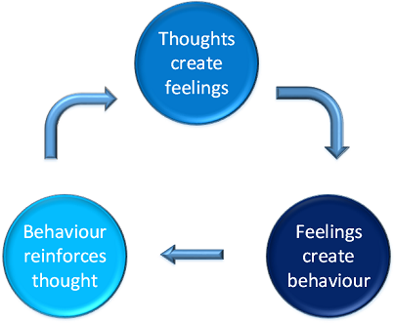
“Making sense of CBT”
https://www.youtube.com/watch?v=9c_Bv_FBE-c
Useful self-help CBT website:
https://llttf.com/

Panic Attacks
Panic attacks are commonplace. Most people will experience one at some point in their lives
The person may feel like they are having a heart attack or that they have to leave the situation – quickly!
The panic attack will probably reach peak intensity within 10 minutes and then stop
It is distressing and debilitating but not fatal – no-one has ever died of a panic attack. Their heart won’t use up all its beats!
Signs and Symptoms of Panic Attacks
Pounding heart, palpitations
Chest pains
Sweating
Trembling or shaking
Shortness of breath
Choking feeling
Feeling sick
Dizziness
Feel that you're observing yourself from outside your body
Fear of losing control or losing sanity
Fear of dying

How to help someone who is having a panic attack
- Make sure they’re not having a heart attack (if in doubt 999!)
- Give the person plenty personal space
- Speak kindly, calmly and confidently
- Assure them this situation is temporary and harmless
- Get the person to breathe in through the nose with you for 5 counts, hold for 3, then breathe out for 5
- Get the person to focus on their toes, curling them for 5 then relax
- Use distraction techniques – e.g. number sequences
- Stay with them (be a comfort)
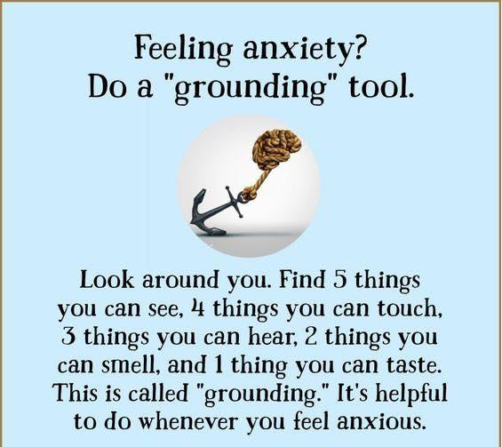

Section 3 – Psychosis

What is Psychosis?
- Losing touch with reality
- Hallucinations – the person sees, hears, smells, tastes or feels things that don't actually exist outside their mind
- Delusions – unshakable beliefs in something untrue (e.g. people are out to harm them, or that they have influence and power beyond reality)
- Confused or disturbed thoughts
- Lack of insight in to what is real
What can cause a Psychotic episode?
- Excessive abuse or stress
- A head injury
- Side-effects of medication
- Infections in elderly people
- High temperatures in children
- Psychotic illness, e.g. schizophrenia or bipolar disorder

Schizophrenia
- Not a split-personality (e.g. Jekyll and Hyde)
- Usually begins between 15-20 years old
- Leads to feeling threatened, paranoia
- Marked by hallucinations and delusions
- Signs that an episode is developing. The person is:
feeling suspicious or fearful, worrying about people's motives
hearing quiet voices now and again
finding it difficult to concentrate

Bipolar Disorder
- Periods of mania
Understanding Bipolar Disorder https://www.youtube.com/watch?v=B139W3-GZTo
- Periods of depression

Helping someone who is having a psychotic episode
- Tell them who you are and that you want to help
- Sit down (on the chair nearest the door!), speak calmly, quietly and kindly
- Don’t agree or argue with the delusion/hallucination
- Don’t laugh at the delusion
- Explain that you cannot hear (see) what the person is hearing (seeing) but say that you believe that it is real to them and acknowledge that it’s causing them distress
- Ask them if you can call their CPN
- If there seems to be any risk call police and/or ambulance
Section 5 – Suicide (download NLC Suicide Prevention app to your phone)

Do people attempt to complete suicide because they want to die?
Most people who attempt suicide do not want to die. They simply don’t want to live and don’t see any other solution to their situation.

Why Do We Not Talk about Suicide?
- Shame and embarrassment
- Associated with crime/sin
- Prejudice

Why do we not ask if someone is considering suicide?
- In case we put the idea in their head! (This, of course, is a fallacy!)
- In case they angrily react at such a suggestion
- In case they say “YES” – and now we feel responsible to keep them alive!

Indicators or invitations to ASK about suicide include:
  - Lack of personal hygiene/care
  - Extreme risk-taking behaviour
  - Unusual behaviours (e.g. giving things away)
  - Putting “house in order”
  - Complete and inexplicable change in demeanour (negative or positive)
  - Statements expressing:
Hopelessness, despair - inability to see a future
No purpose/point in living

How to ask the question
- Avoid euphemisms! Be direct and clear! Use the Indicator or Invitation
For example:
‘Sometimes when people are [indicator/invitation] they have thoughts of suicide. Are you thinking about suicide?’
What if they say “Yes!”?
- Do not leave the person alone
- Make the person safe by removing means if possible
- Find out who can support the person
- Encourage the person to talk
- Ask if they have decided when and how they will complete suicide – indicates the potential imminence of a suicide attempt

Options
- Dial 999 and ask for an ambulance
- Take the person to A&E
- Call Breathing Space 0800 83 85 87 (pass on to Nicolette Harris in HR)
- Childline 0800 1111 (pass on to Tom Dickson, Wellbeing Officer)

The Importance of Listening
- Needs to be non-judgemental and empathetic
- It enables a person to see what they’re thinking from an objective perspective and they may talk themselves out of the desire to die
- Never underestimate the value of simply “being there”
- Don’t do a lot of talking and don’t try and solve/fix the problem

Never put yourself in danger:
- Keep calm
- If in doubt move to a safe distance
- Call for urgent help
- It can be rewarding but also very upsetting
- Talk to someone about your own stress and/or distress
- Be good to yourself!
“I survived Golden Gate Bridge Jump”
https://www.youtube.com/watch?v=WcSUs9iZv-g

Section 6 - Listening Skills
“Being heard is so close to being loved that for the average person, they are almost indistinguishable.” David Augsburger

Remember from the role play – learn from all the intentional errors!

Show that you are listening!
- Pay attention
- Nod, make encouraging gestures
- Reflect - What I’m hearing you say is… Is that right?
- Understand – What do you mean when you say…?

Be non-judgemental!
- It’s about accepting the person, not their value system
- Respect the person and their right to make wrong choices
- Resist the urge to fix the person or solve the problem
- Ask open questions, never ask, “Why….?”

Asking a young person about how they are
- Allow them time to talk, don’t mistake silence for disinterest
- Don’t be superior
- Don’t trivialise
- Don’t tell them you know what they’re going through

“I've learned that people will forget what you said, people will forget what you did, but people will never forget how you made them feel.” Maya Angelou

Section 7 – Positive Mental Health

What does positive mental health look like?
- Emotionally stable
- Confident
- Resilient, coping with crisis
- Productive and fruitful
- Functioning well
- Realising potential
- Enjoying day to day life

The Happy Chemicals and how to facilitate your brain’s release of them
Dopamine - Released when you approach a reward or achieve a goal
- Make a “to do” list and tick ‘em off!
- Be creative
- Exercise (goal focussed – get a Fitbit!)
- Keep the winning streak going
- Listen to music (the good stuff that has a positive effect on you!)
Seratonin - Released when you feel valued, significant and purposeful
- Enrich your diet with B Vitamins
- Embrace sunlight and Vitamin D
- Eat tryptophan enriched foods (google what they are!)
- Exercise (3 x 10 minutes cardio daily)
- Engage in good sleeping habits (average 7-8 hours a night)
Oxtytocin - Released when you feel secure, connected and loved
- Loving (sex, hugging)
- Living an adventurous life with others
- Listening well (connecting with someone’s heart – i.e., being empathetic)
- Laughing together
- Giving gifts (even more than receiving)

Endorphins - Released when you feel euphoric or any natural extreme
- Exercise (runner’s high)
- Physical pain
- Eating certain foods (dark chocolate/spicy food – google the rest!)
- Laughter (or even anticipating a laugh)
- Anything that creates a (legitimate!) feeling of pleasure

Things that promote positive mental health
- Exercise – 1 Timothy 4:8 “Physical exercise is profitable!”
- Food – Philippians 3:19 “Their god is their stomach…”
- Rest – Mark 6:31 “Come with me by yourselves to a quiet place and get some rest.”
- Sleep – Psalm 127:2 “In vain you rise early and stay up late…”
- Doing new things – Ephesians 2:10 “We are God’s workmanship, created in Christ Jesus to do good things…”
- Laughter – Proverbs 17:22 “A cheerful heart is good medicine”
- Music – Ephesians 5:19 “Sing and make music in your heart to the Lord”
- Relationships – Philippians 2:25 “..my brother, co-worker and fellow soldier…”
- Ministry – Matthew 11:28 “Walk in the unforced rhythms of grace…”
- Thanksgiving – 1 Thessalonians 5:18 “…be thankful in all circumstances…”
- Truth – 1 John 3:1 “See what great love the Father has lavished on us…”

